**Inclusivity and Accessibility Examples from the Trash Warrior App**

**The group analyzed the audience.**

###### - Inclusivity and Cultural Analysis

The users range in age from middle school to senior citizens. Individuals and large groups can use the app to claim a plot of trash to eradicate. Users may range from novice to expert level with technology.

The app will need an option to enlarge fonts to accommodate visual impairment. Some users may have physical limitations or disabilities and may need to know if the site is accessible. Also, those with physical disabilities may not be able to lift heavy items.

**The group came up with a persona for one of our users.**

**Marge**

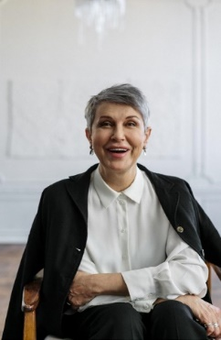

Single, long-term user (trash volunteer)

Marge is a 73 year-old retiree who would like to perform some type of community service in her spare time. Marge isn’t really great with technology, but she can use apps if someone installs them and shows her how to use them. Marge wears reading glasses and would benefit from a larger font. She also recently had knee surgery and can’t walk on uneven terrain or lift anything over 20 pounds.

Goals

* Marge would like to use the app once a month to find trash to collect.

Where we can help

* Use larger fonts
* Include a small help menu
* Create a way to indicate the terrain of the site
* Create a way to indicate the amount of trash and if it includes heavy items

**The icons can help determine which areas may contain heavy items to lift.**

**Trash app icons 
Trash bag icon-location and number of bags
Hazmat icon-denotes hazardous materials
Tiger team icon-larege items
Tire icon-large items that can be carried by hand
Warning icon-poisous plants**

**Inclusivity and cultural decisions are included in the project.**

##### **Inclusivity and Cultural Decisions**

This app will be designed for those of all ages and abilities. There are two main areas to consider in the design of this app: accessibility of the area where the trash is to be removed and accessibility and inclusivity on the app itself. The design of the app should help to mitigate inaccessibility for both.

The amount of trash and terrain of some sites may make them impossible for some users to clean some areas. Some features built into the app could make the app more incluse for such users. These features include:

* A feature that allows those who report trash to identify large items and estimate the amount of trash. This feature will also allow trash reporters to take a photo of the trash;
* A feature that allows those who report trash to identify any terrain hazards and rate the accessibility of the physical location; and
* A feature that allows those volunteering to indicate any limitations they have so that the administrator can assign them to a pick-up site accordingly.

The app will also need to be accessible and inclusive. App features include:

* Larger fonts for those with visual impairments and the elderly;
* A help menu for those who are inexperienced with technology;
* A feature that allows users to sign up individually or as a group.